Name_________________________________________________ Period_______ Date______________

Proteins Synthesis Worksheet
IB Biology

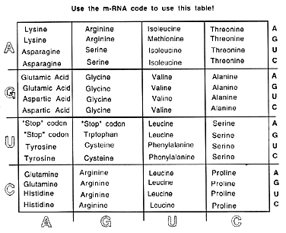

1. Given the following DNA code: AGG CTC CGA GTA ACT

- A. What is the mRNA code?

- What is the tRNA code?

- What are the 5 amino acids coded by the above piece of DNA (in order from left to right)?

2. Given the following DNA code: GTT TCC AAC ATT CGC

- A. What is the mRNA code?

- What is the tRNA code?

- What are the 5 amino acids coded by the above piece of DNA (in order from left to right)?

3. Given the following tRNA code: CAU UUU GGG AUC UGC

- What is the mRNA code?

- What is the DNA code?

- Determine the DNA code for the amino acid known as Tryptophan.

- m RNA code:

- DNA code:

- What are the amino acid components of the following DNA code? List the amino acids in order from left to right designated by the DNA.

DNA: GGA CTA ACA GAA GAG TCA ACA

- mRNA:

- tRNA:

- amino acids:

- What is the DNA code of the following protein? The letters for the tRNA are given below each amino acid.

Amino Acids: Methionine Valine Cysteine Arginine

tRNA: UAC CAA ACA GCA

mRNA: _______ __ __________ _______ __ __________

DNA: _______ __ _______ __ _______ __ __________

- List the three DNA triplets that correspond for stop codes.

8. Why is it important that there are extra triplet codes corresponding for each amino acid?

