Name_________________________________________ Period________ Date__________________

Estimating Cell Size and Calculating Drawing Magnification

Drawing Magnification = Length of Drawing ÷ actual length of beastie

1. 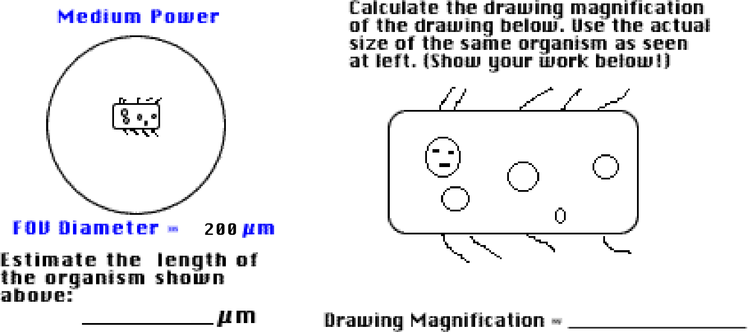

2. 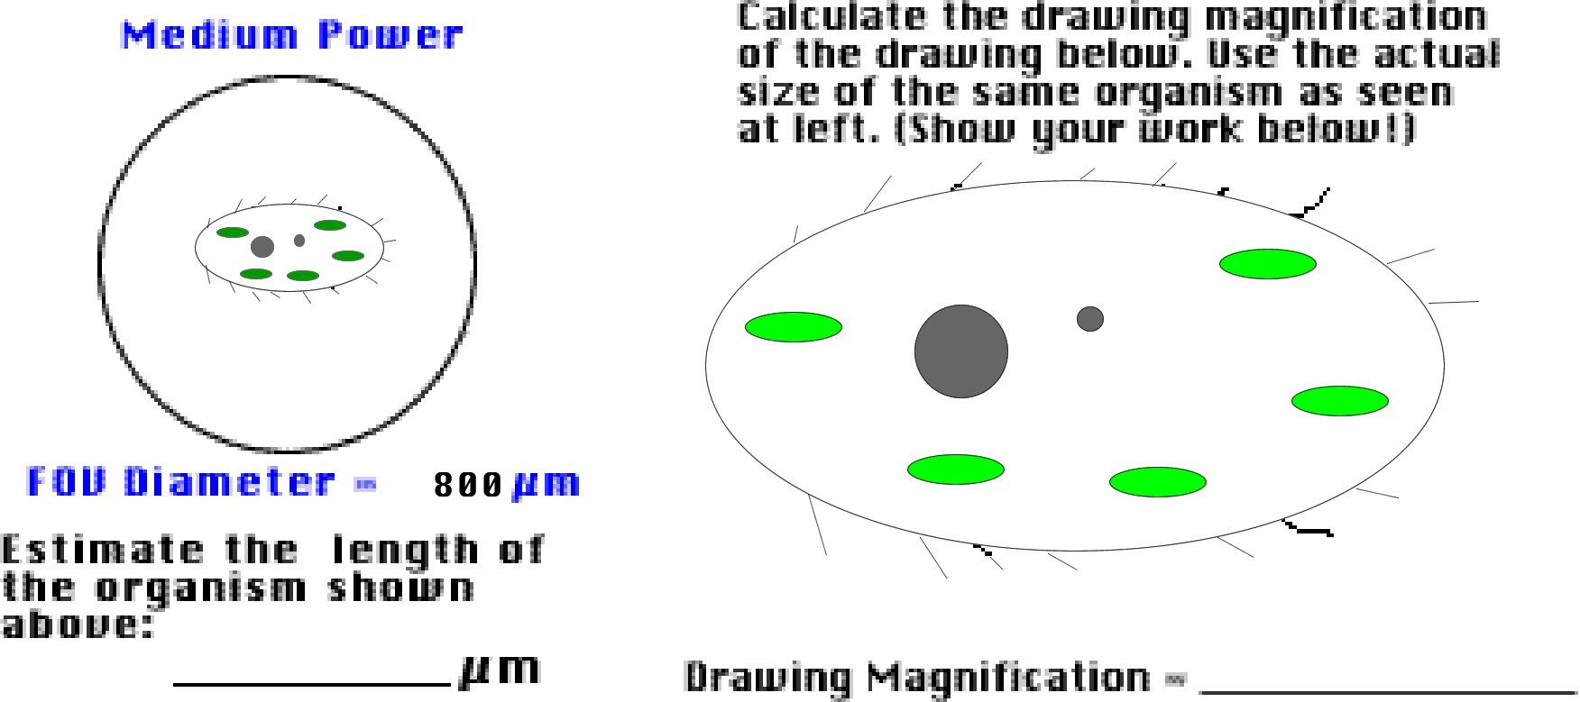

3. 